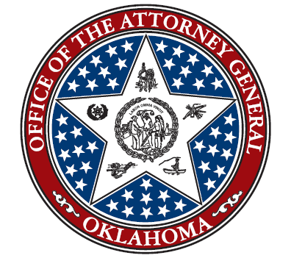

Criminal Justice Reclassification Coordination Council
Office of the Oklahoma Attorney General

Special Meeting
December 6, 2021
3:00PM
Office of Oklahoma Attorney General
313 N.E. 21st St
Oklahoma City, OK 73105

AGENDA

- Welcome
- District Attorney Steve Kunzweiler

- Roll Call, Recognition of Quorum, Statement of Compliance with OMA and Possible Action to Approve Minutes of 9/23/2021 meeting
- District Attorney Steve Kunzweiler

- Presentation, Discussion and Possible Action to Adopt Final Report of the Reclassification Council- District Attorney Steve Kunzweiler

- Announcements/Adjourn
A. District Attorney Steve Kunzweiler

